**Plotting Our React Blocks (Optional)**

Using what we've learned about styles, let's recreate the famous "Plotting your Blocks" assignment from Web Fundamentals this time using React Components.

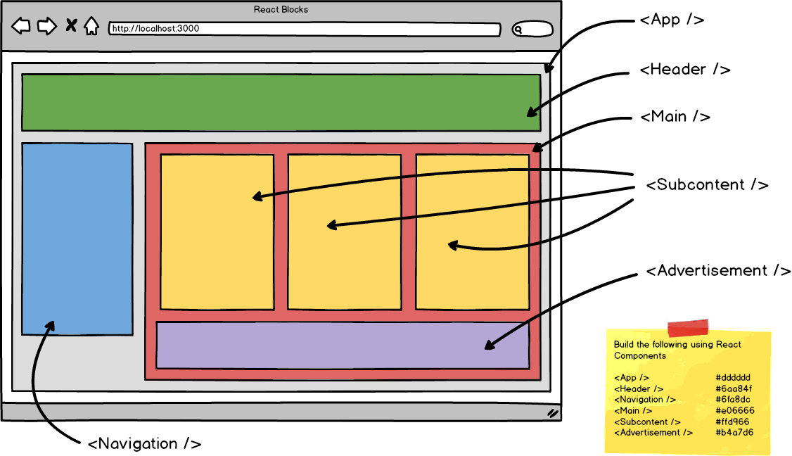

We can consider writing something like this where Header, Navigation, Main, SubContents, and Advertisement are all components we will need to import into the App.js and the Main component can display {props.children}.

import React from 'react';

import './App.css';

import Header from './Components/Header';

import Navigation from './Components/Navigation';

import Main from './Components/Main';

import SubContents from './Components/SubContents';

import Advertisement from './Components/Advertisement';

*function* App() {

return (

<div className="app">

        <Header />

        <Navigation />

        <Main>

            <SubContents />

            <SubContents />

            <SubContents />

            <Advertisement />

        </Main>

    </div>

);

}

export default App;